For Release: December 23, 2024
Contact: Timothy Aylor, Senior Economist
Economic Information & Analytics Division
(804) 786-3976 or (804) 786-7496
LMI@virginiaworks.gov

Follow us on Twitter: @VirginiaLMI
Virginia Job Openings Increase in October; Layoffs, Quits, and Separations Decrease
RICHMOND— Virginia Works (the Virginia Department of Workforce Development and Advancement) announced today that the U.S. Bureau of Labor Statistics’ October 2024 Job Openings and Labor Turnover Survey (JOLTS) reports decreases in Virginia hires, layoffs, and quits.
According to the most recent BLS JOLTS survey data, the number of October 2024 layoffs and discharges in Virginia decreased by 6,000 over the month but were equivalent to that of five years earlier. BLS JOLTS data provides information on all the pieces that go into the net change in the number of jobs. These components include job openings, hires, layoffs, voluntary quits, and other job separations (which includes retirements and worker deaths). Putting those components together reveals the overall change in payroll employment. JOLTS data is seasonally adjusted and describes conditions on the last business day of the month. Current month’s data are preliminary and the previous month’s data have been revised.
On the last business day in October, there were 276,000 job openings in Virginia, seasonally adjusted, an increase of 52,000 from September’s revised figure. Nationwide, the number of job openings was little changed at 7.7 million on the last business day of October but was down by 941,000 over the year. The number of job openings significantly increased in professional and business services (+209,000),
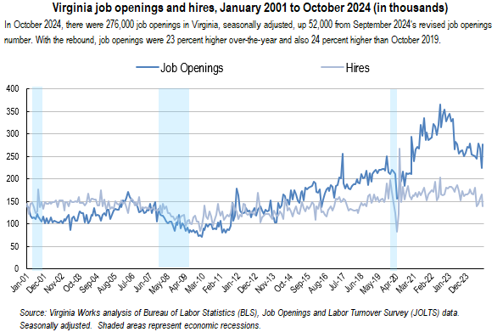
accommodation and food services (+162,000), and information (+87,000) but decreased in federal government (-26,000). The largest increases in the job openings level occurred in Colorado (+134,000), Georgia (+81,000), and Texas (+77,000). The largest decreases occurred in New York (-98,000), Pennsylvania (-54,000), and Arkansas (-15,000). In Virginia, the October job openings rate rose to 6.1 percent, an increase from September’s revised rate. The U.S. job openings rate, at 4.6 percent, changed little over the month. Nationwide, the largest increases in job openings rates occurred in Colorado (+3.8 percentage points), Mississippi (+1.7 points), and Georgia (+1.5 points). The largest decreases occurred in New Hampshire (-1.3 points), Arkansas (-1.0 point), and New York (-0.9 point).
The number of hires in Virginia fell to 139,000 in October, a decrease of 26,000 over the month and down by 22,000 from October 2023. JOLTS defines hires as all additions to the payroll during the month. In October, the number of U.S. hires changed little at 5.3 million but was down by 501,000 over the year. Hires significantly decreased in private educational services (-24,000). The largest decreases in the hires level occurred in Florida (-82,000), Michigan (-43,000), and New York (-37,000). The increases occurred in Colorado (+24,000) and Oklahoma (+15,000). In Virginia, the 3.3 hires rate decreased from September’s revised 3.9 percent rate. The U.S. hires rate was little changed at 3.3 percent. The U.S. hires rate for establishments with 1 to 9 employees decreased in October. Significant decreases in the hires rates

occurred in Montana (-2.0 percentage points), Michigan (-1.0 point), and Florida (-0.8 point). Significant increases occurred in Oklahoma (+0.9 point) and Colorado (+0.7 point).
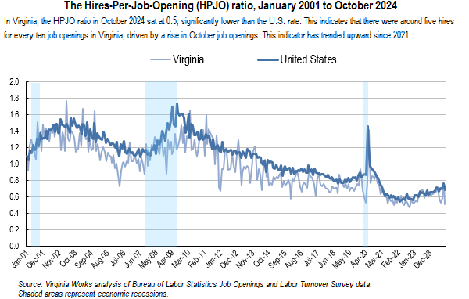
The Virginia hires-per-job-openings (HPJO) ratio fell in October to five hires for every ten job openings, lower than nationwide. This measure shows the rate of hiring compared to open jobs and is a proxy for time to fill positions.
In October 2024, there were 0.5 unemployed per job opening in the Commonwealth, compared to 0.9 unemployed per job opening nationwide. In Virginia, the unemployed per job opening ratio (sometimes called the ‘job seekers ratio’) peaked at 4.4 unemployed per job opening in February 2010 during the Great Recession, while the number of unemployed workers per job opening stood at 0.3 in April 2020 during the height of pandemic employment impacts.
Total job separations in Virginia decreased by 8,000 to 142,000. Nationwide, the number of total separations in October was little changed at 5.3 million but was down by 369,000 over the year. The largest increases in the total separations level occurred in California (+83,000), Colorado (+73,000), and Arizona (+31,000). The decreases occurred in New York (-76,000), Florida (-69,000), and Pennsylvania (-31,000). The Virginia total separations rate edged down to 3.3 percent, little changed over the month and at levels typical in recent months. The U.S. total separations rate was 3.3 percent for the third month in a row. Nationwide, significant increases in total separations rates occurred in Colorado (+2.4 percentage

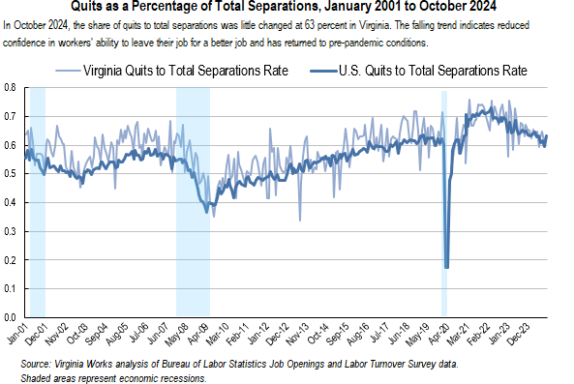
points), Alaska (+1.5 points), and Wyoming (+1.3 points). The decreases occurred in New York (-0.8 point) and Florida (-0.7 point). An estimated 89,000 workers quit jobs from Virginia employers in October. The number of quits decreased by 3,000 from September’s revised figure. This was ten percent lower over-the-year and 18 percent lower than five years earlier. In October, the number of U.S. quits increased to 3.3 million (+228,000) but was down by 308,000 over the year. The largest increases occurred in California (+78,000), Colorado (+43,000), and Arizona (+26,000). Significant decreases occurred in Florida (-54,000) and Pennsylvania (-28,000). The quits rate in the Commonwealth was 2.1 percent and remained at levels seen over the last two years. Over the month, the U.S. quits rate increased to 2.1 percent. Nationwide, the largest increases in quits rates occurred in Wyoming (+1.7 percentage points), Colorado (+1.4 points), and Alaska (+1.2 points). Significant decreases occurred in Florida and Pennsylvania (-0.5 point each). The October ‘churn’ rate (the sum of the hires rate and total separations rate) in Virginia slowed by 0.8 of a percentage point from September’s revised 7.4 percent figure. The U.S. churn rate was little changed over the month. While more volatile month-to-month, Virginia’s pace has been more active for over a year.
The number of layoffs and discharges in Virginia was 44,000 in October, a decrease of 6,000 from September’s 50,000 revised estimate. This was down four percent over the year. Layoffs and discharges are countercyclical, which means that layoffs typically increase during economic contractions and decrease during economic expansions. Nationwide in October, the number and rate of layoffs and discharges

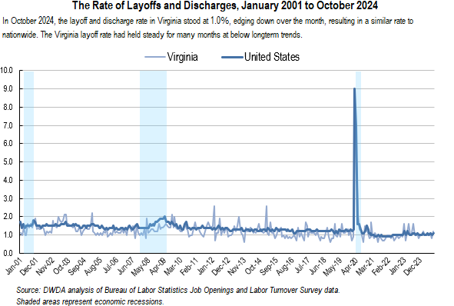
changed little at 1.6 million and 1.0 percent, respectively. Layoffs and discharges increased in retail trade (+60,000) but decreased in durable goods manufacturing (-37,000) and in private educational services (-14,000). The largest decreases in the layoffs and discharges level occurred in New York (-80,000), Ohio (-40,000), and Georgia (-16,000). The increase occurred in Colorado (+29,000).
The Virginia layoffs and discharges rate was one percent in October. The U.S. layoffs and discharges rate was also one percent in October. The largest decreases in layoffs and discharges rates occurred in New York (-0.8 percentage point), Ohio (-0.7 point), and Missouri (-0.4 point). The increase occurred in Colorado (+1.0 point). Over the month, the national layoffs and discharges rate increased (+0.1 point).
On the last business day of October, JOLTS data showed slowing but resilience in Virginia’s labor market. Job openings rebounded in October and continued to illustrate available opportunites for job seekers. The challenge remains that it also shows the difficulty that many employers have had in hiring key occupations requiring in-demand skills. After rising in September, the estimate of job hires fell to their lowest level since May 2020. At the same time, total job separations also decreased, led by fewer layoffs and discharges. These resulted in a one-to-one hires-to-separations rate, with slower velocity of movement from job to job.
Job Openings
Job openings include all positions that are open on the last business day of the reference month. A job is open only if it meets the following three conditions: (1) A specific position exists and there is work available for that position; the position can be full time or part time, and it can be permanent, short term, or seasonal; (2) the job could start within 30 days, whether or not the employer can find a suitable candidate during that time; and (3) the employer is actively recruiting workers from outside the establishment to fill the position. Excluded are positions open only to internal transfers, promotions or demotions, or recalls from layoffs.

Hires
Hires include all additions to the payroll during the entire reference month, including newly hired and rehired employees; full-time and part-time employees; permanent, short-term, and seasonal employees; employees who were recalled to a job at the location following a layoff (formal suspension from pay status) lasting more than 7 days; on-call or intermittent employees who returned to work after having been formally separated; workers who were hired and separated during the month; and transfers from other locations. Excluded are transfers or promotions within the reporting location, employees returning from a strike, and employees of temporary help agencies, employee leasing companies, outside contractors, or consultants.

Separations
Separations include all separations from the payroll during the entire reference month and are reported by type of separation: quits, layoffs and discharges, and other separations. Quits include employees who left voluntarily, except for retirements or transfers to other locations. Layoffs and discharges include involuntary separations initiated by the employer, including layoffs with no intent to rehire; layoffs (formal suspensions from pay status) lasting or expected to last more than 7 days; discharges resulting from mergers, downsizing, or closings; firings or other discharges for cause; terminations of permanent or short-term employees; and terminations of seasonal employees (whether or not they are expected to return the next season). Other separations include retirements, transfers to other locations, separations due to employee disability, and deaths. Excluded are transfers within the same location, employees on strike, and employees of temporary help agencies, employee leasing companies, outside contractors, or consultants.

*Excerpted from U.S. Bureau of Labor Statistics, Handbook of Methods, "Job Openings and Labor Turnover Survey: Concepts," https://www.bls.gov/opub/hom/jlt/concepts.htm.
Virginia Works plans to release the November 2024 analysis of the BLS Job Openings and Labor Turnover Survey for Virginia on Tuesday January 21, 2025. The data for all states and the U.S. will be available on the BLS website JOLTS page, at https://www.bls.gov/jlt/. BLS is scheduled to release the November JOLTS data for states on Friday, January 17, 2025.

Technical note: Effective with the release of May 2024 data on July 24, 2024, the Job Openings and Labor Turnover Survey (JOLTS) state estimates have been benchmarked and revised to include the annual benchmark revisions to JOLTS national estimates, the Current Employment Statistics (CES) employment estimates, and the Quarterly Census of Employment and Wages (QCEW) data. Seasonally adjusted and not seasonally adjusted data from January 2019 forward are subject to revision. The Bureau of Labor Statistics (BLS) Job Openings and Labor Turnover Survey (JOLTS) produces monthly data on U.S. and regional job openings, hires, quits, layoffs and discharges, and other separations from a sample of approximately 21,000 establishments. As a supplement, BLS has begun publishing state estimates that provide monthly information that can be used to better understand the dynamic activity of businesses in state economies that leads to aggregate employment changes. For more information on the program’s concepts and methodology, see “Job Openings and Labor Turnover Survey: Handbook of Methods” (Washington, DC: U.S. Bureau of Labor Statistics, July 13, 2020), https://www.bls.gov/opub/hom/jlt/home.htm. For more information on BLS’ state JOLTS estimates, see https://www.bls.gov/jlt/jlt_statedata.htm. Definitions of JOLTS terms*
###

